Registration of Third-Party Applications

March 21, 2022

# Overview

In this document, we describe functionality that allows developers to register third-party applications that utilize the Dashboard API. Specifically, we will provide (1) a web form that developers can use to provide details of their application, and (2) a web page listing the available applications, for Dashboard users to access them. The overall process is a follows:

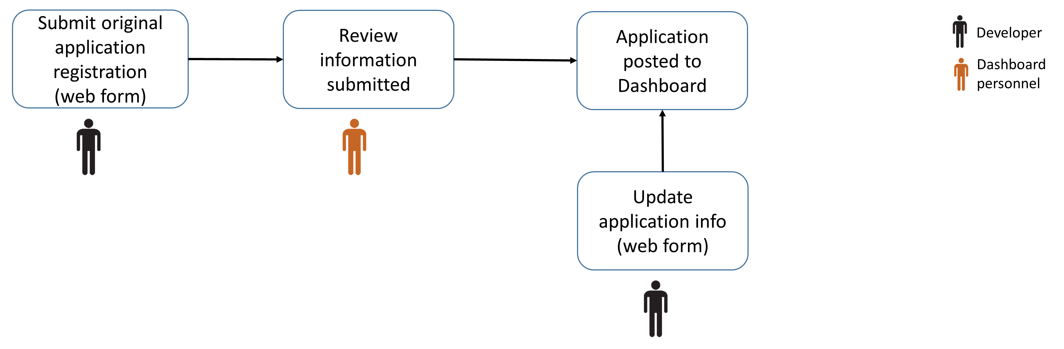

**Figure 1**: Third-party application registration workflow

# Top-level Menu Reorganization

Access to the new functionality will be via the “Resources” menu item. To that end, and to organize more compactly the menu, the structure of the “Resources” menu item will be reorganized as follows (in red font, the menu items discussed in this document):

* OCG/CTD2 Home Page
* How to Cite
* API Documentation
* Applications
  + Application Registration (Developers)
  + Dashboard Applications
* Network Resources
  + CTD2 Home Page
  + Publications
  + Data Portal – Downloads
  + Analytical Tools
  + Supported Reagents
* Outside Resources
  + LINCS

# Application Registration (Developers) – Menu Item

Clicking on the menu item “Resources->Applications->Application Registration (Developers)” will bring up a page to allow developers to register a new external application or to make changes to a previously submitted one. The page will be titled “***Application Registration***” and will open with the following text:

The [CTD2 Dashboard API](https://ctd2-dashboard.nci.nih.gov/dashboard/#api-documentation) allows programmatic access to the Dashboard data, to facilitate development of third-party applications that provide improved visualization capabilities as well as integration with external data sources. Using the application registration form below, developers can register their application with the Dashboard so that Dashboard users can find and access them. After the form is submitted, it will be reviewed by the Dashboard team and a link to the application will be added to the “Dashboard Applications” page. Developers will also receive by e-mail a unique code, which can be used in the future to make changes to the registration form.

Register new application Modify existing registration

## Modify existing registration

Clicking on the “Modify existing registration” link will open (in the same page, just below the two links above) the following text:

When you submitted your original application registration form, you received an e-mail with a unique code. Please enter that code below to modify the application information you submitted. If you have lost the code, please e-mail us at [ctd2-dashboard@cumc.columbia.edu](mailto:ctd2-dashboard@cumc.columbia.edu) so that we can resend it to you. Please make sure to include your application’s name in your message.

<1-line text area, for users to enter application code>

Submit

Clicking on “Submit” will cross-reference the user-provided application code against all application records in the database. If no application is found with that code, then the following error message will be displayed:

The code you provided does not match any application. Please try again.

If an application record is matched, then the web form described below in **Table 1** will appear (in the same page, just below the text area above) pre-populated with the values from the relevant application record. Developers can proceed to modify and resubmit the form, as described in the workflow of the following section.

## Register new application

Clicking on the “Register new application” link will open (in the same page, just below the links “Register new application” and “Modify existing registration”) a form with the following fields. Next to each field title there should be a question mark icon, which will provide hover-over text; the text to use is listed under the “Help” column in the table below. Asterisks indicate required fields.

|  |  |  |
| --- | --- | --- |
| **Field Title** | **Field Type** | **Help** |
| Application Title* | Text | A short application title, no more than 30 characters. |
| URL* | URL | Application URL, this is where the Dashboard link will point. |
| Application Description* | Text | One paragraph description of the application functionality. |
| Developer Name* | Text | Name(s) of application developer(s). Please separate multiple entries by commas. |
| Contact e-mail* | E-mail | E-mail where Dashboard personnel can contact you. This e-mail will also be used to receive a unique code that can be used to modify the application registration information submitted through this form. |
| Institution* | Text | The institution(s) the developer(s) are affiliated with. Please separate multiple entries by commas. |
| Lab Name | Text | The name of the lead investigator(s) of the lab(s) where the application was developed, if applicable. Please separate multiple entries by commas. |
| Image | Image | A 300 x 150 pixel image (width x height) to be associated with the application in the Dashboard page, if desired. |

**Table 1**: Fields in application registration web form.

At the bottom of the form, there should be a “Submit” button to use when the form editing is completed, with an associated CAPTCHA challenge to protect against bots. Clicking the button will fist validate the form, i.e., confirm that all required fields are completed and that the information entered complies with the field type specification described in the table above. If something is wrong, the application should provide an error message identifying the problem, i.e., specifying which required fields are missing values or/and which values are not formatted as expected. What happens after the form is successfully validated depends on which link/button the user originally clicked:

* If the form was completed in response to clicking on “Register new application”:
  + A new database record is generated for the user application, capturing the information submitted in the registration form. In addition to fields for storing application info collected through the form, the record also contains fields titled “status” and “app_code”.
  + The “status” field within the new record is set to “pending”, to indicate that the application is not year released.
  + A new unique code is generated for the application. The code is stored in the “app_code” field and e-mailed to the form submitter, using the e-mail address provided under “Contact e-mail”. The message to the form submitter is titled   
     Code for your CTD2 Dashboard application   
    and the message body reads:  
     Dear Developer, thank you for registering your application with the CTD2 Dashboard. We are in the process of reviewing your application; we will notify you when it has been published. This is your unique application code: <code_here>. You can use it at any time to edit the application information you submitted, by revisiting the application registration web page.  
      
    Sincerely,  
    The CTD2 Dashboard team
  + An e-mail message is sent to [ctd2-dashboard@cumc.columbia.edu](mailto:ctd2-dashboard@cumc.columbia.edu), titled “New CTD2 Dashboard application registration”. The contents of the message include the data captured in the registration form.
* If the form was completed in response to selecting “Modify existing registration”:
  + The database record for the application is update with the new form data.

## Registration Request Review

A new application registration request triggers a message to [ctd2-dashboard@cumc.columbia.edu](mailto:ctd2-dashboard@cumc.columbia.edu). Following receipt of the message, Dashboard personnel should perform basic due diligence (check the application URL and functionality, confirm that the developer and the institution info provided is legit, etc.) If everything checks out, the status of the application record in the database should be changed from “pending” to “published” and a message should be sent to the application developer (using the e-mail address provided under “Contact e-mail”) to let them know that their application is now available from the Dashboard. Otherwise, the application record should be deleted altogether from the database.

Developers can also directly e-mail [ctd2-dashboard@cumc.columbia.edu](mailto:ctd2-dashboard@cumc.columbia.edu) when they have misplaced the unique application code they received when the submitted their original registration request. In such cases, Dashboard personnel will retrieve the code from the database and send it to the developer (via reply to the original request e-mail).

The modifications and communications described above will be handled manually. In the next iteration of the Dashboard development, we can consider adding an admin page to carry out these and similar tasks.

# Dashboard Applications – Menu Item

Clicking on the menu item “Resources->Applications->Dashboard Applications” will bring up a new page titled “***Dashboard Applications***” which will list all registered third-party applications whose status is “published”. The following text will appear after the page title and before the application list:

The applications listed below provide additional ways to view and use the Dashboard data. They are developed by third parties, leveraging the Dashboard API. These applications are the responsibility of their developers and are not created or maintained by the NCI

Applications should be listed in badged form, similar to:

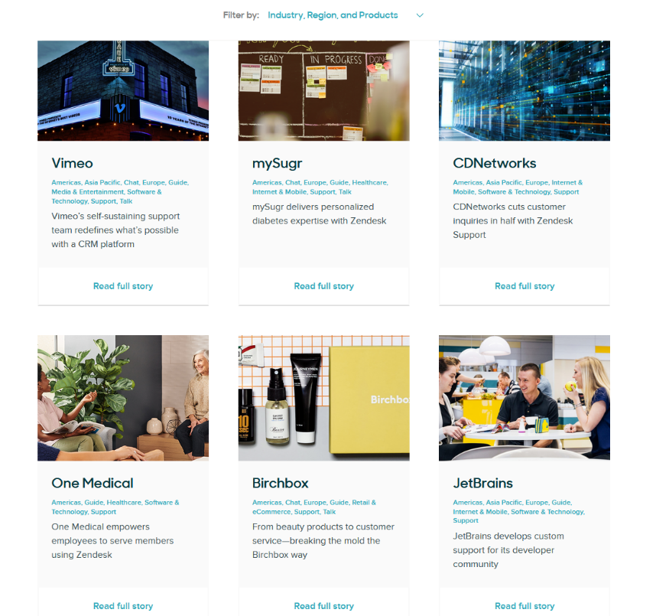

For each application, the following information will be displayed:

* The 300 x 150-pixel application image, if one was submitted with the registration form. Otherwise, a generic application image will be used. The image will be hyperlinked to the application URL provided in the registration form.
* The short application title provided in the registration form. The application title will also be hyperlinked to the application URL.
* The first 100 characters from the application description provided in the registration form. If the description comprises more than 100 characters, a “more” link will be placed at the end of the 100 characters. When the “more” link is clicked, the full application description will be displayed in a scrollable popup text window.
* A link titled “Developer information”. When the link is clicked, the developer information provided in the registration form will be displayed in a scrollable popup text window, per the example below:  
   Institution(s): Columbia University, Broad Institute  
   Developer(s): Zhou Ji, Vlado Dancik  
   Lab(s): Aris Floratos, Paul Clemons
* A link titled “Go to application” which will hyperlink to the application URL.