CSV file to MySQL DB Insert

Introduction
This process will take the contents of a CSV file, create an MySQL insert statement and execute it. See CSV File – Example Content for example input. The table name is provided to the process as parameters, see Parameters below.

Triggering
Type | System | Settings | Comments
Manual | Frends

Process Variables
Name | Comment
FilePath | Full path of the target file to be read
FileName | Name of the target file to be read
ServerAddress | Address of the SFTP Server
ServerUser | User for the SFTP Server
ServerPassword | Password the SFTP Server
TableName | Name of the database table into which the data is to be inserted
ServerAddress | Address of the SFTP Server
ConnectionString | Connection details for the database.

Process Details

Process Diagram
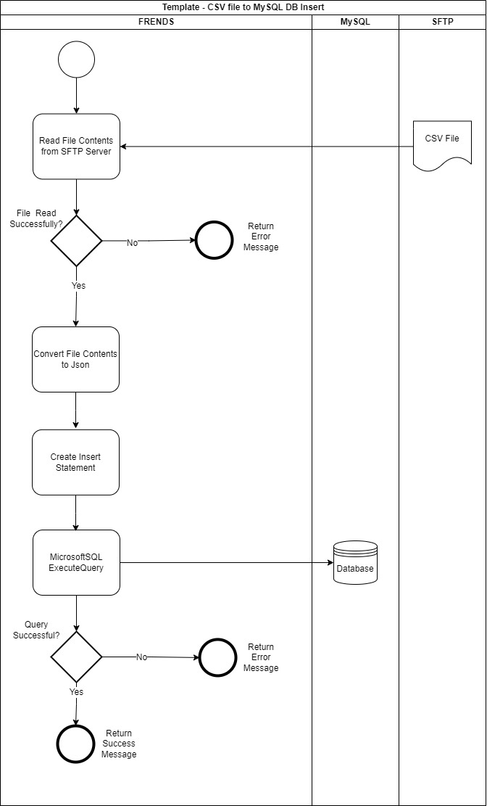

Process Steps
Step No | Process Step | Implementation Details
1 | Process starts | A manual trigger is activated with the Process Variables described above.
2 | Read File Contents from SFTP Server | Use the SFTP ReadFile task to get the contents of the CSV file
3 | Was the read successful? | If the “Success” field in the result from the file read in step 2 was false go to the next step (step 4), otherwise continue from step 5.
4 | Stop processing and return error message | Return a meaningful, plain English error message.
5 | Convert the CSV content to Json | Use the ConvertToJSON task to convert the CSV data to Json.
6 | Build Insert Statement | Create the Insert statement using the TableName Process Variable. For the Columns definitions use property name from the Json created in step 5  Use the property value from each line from the Json created in step 5 for the value clause.
7 | MySQL ExecuteQuery | Execute the Insert statement from step 6 on the database using the MySQL ExecuteQuery task.
8 | Was the Insert successful? | If the “Success” field in the result from the execution of the Insert in step 7 was false go to the next step (step 9), otherwise continue from step 10.
9 | Stop processing and return error message | Return a meaningful, plain English error message.
10 | Stop processing | Terminate the process and return success message.

Solution components
Subprocess | Description | Tags
Error Handler | Handles any error that occurs

Data flow

Environment variables
These are process specific environment variables. General environment variables can be found at <TBD>
Variable name | Description | Dev | Test | Prod

Interfaces and data transfers

SFTP File Read – Step 2
Parameter Name | Source
Input - Path | Process Variables – FilePath + FileName i.e. /input/order.CSV
Connection - Address | Process Variables - ServerAddress
Connection - UserName | Process Variables - ServerUser
Connection - Password | Process Variables - ServerPassword

Example CSV content.
email;address1;address2;country;state;city;zipcode;phone;firstname;lastname;title
dave21@frends.com;1440 River Drive;" #100";USA;CA;Rivertown;12345;123456789;Dave;Twenty-One;Mr
dave21@frends.com;1440 River Drive;" #100";USA;CA;Rivertown;12345;123456789;Dave;Twenty-One;Mr
dave22@frends.com;1440 River Drive;" #101";USA;CA;Rivertown;12345;123487689;Dave;Twenty-One;Mr
dave23@frends.com;1440 River Drive;" #102";USA;CA;Rivertown;12345;563888888;Dave;Twenty-One;Mr
dave24@frends.com;1440 River Drive;" #103";USA;CA;Rivertown;12345;122222229;Dave;Twenty-One;Mr
dave25@frends.com;1440 River Drive;" #104";USA;CA
………

Sample Error Message - Step 4
“An error occurred reading the input file <<FileName>>. Please contact support.”
<<FileName>> = Process Variables – FileName.

Sample Json Data – step 5
{
"Success": true,
"Json": [
{
"email": "dave21@frends.com",
"address1": "1440 River Drive",
"address2": " #100",
"country": "USA",
"state": "CA",
"city": "Rivertown",
"zipcode": "12345",
"phone": "123456789",
"firstname": "Dave",
"lastname": "Twenty-One",
"title": "Mr"
},
{
"email": "dave21@frends.com",
"address1": "1440 River Drive",
"address2": " #100",
"country": "USA",
"state": "CA",
"city": "Rivertown",
"zipcode": "12345",
"phone": "123456789",
"firstname": "Dave",
"lastname": "Twenty-One",
"title": "Mr"
},
{
"email": "dave22@frends.com",
"address1": "1440 River Drive",
"address2": " #101",
"country": "USA",
"state": "CA",
"city": "Rivertown",
.........

MySQL ExecuteQuery - Step 7
Parameter Name | Source
Input – Connection string | Process Variable - ConnectionString
Input - Query | Insert statement created in step 7

Query Example
INSERT INTO contact (email, address1, address2, country, state, city, zipcode, phone, firstname, lastname, title)
VALUES ("user1@frends.com", "street 1", "street 2", "Finland", "Uusimaa", "Espoo", "02700", "0+358407788990", "Joe", "Blogs", "Mr")

Sample Error Message - Step 9
“An error occurred inserting the data into << TableName >>. Please contact support.”
<< TableName >> = Process Variables – TableName.

Sample Success Message - Step 10
“Data was successfully inserted into << TableName >>.”
<< TableName >> = Process Variables – TableName.

