CSV file to MySQL DB Update

Introduction
This process will take the contents of a CSV file, create an MySQL Update statement and execute it. See CSV File – Example Content for example input. The table name is provided to the process as parameters, see Parameters below.

Triggering
Type | System | Settings | Comments
Manual | Frends

Process Variables
Name | Comment
FilePath | Full path of the target file to be read
FileName | Name of the target file to be read
ServerAddress | Address of the SFTP Server
ServerUser | User for the SFTP Server
ServerPassword | Password the SFTP Server
TableName | Name of the database table into which the data is to be inserted
ServerAddress | Address of the SFTP Server
ConnectionString | Connection details for the database.

Process Details

Process Diagram
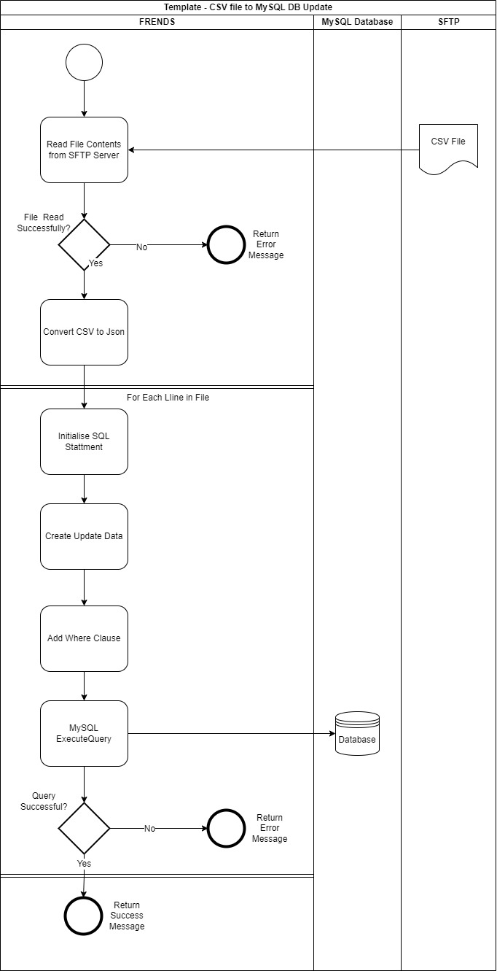

Process Steps
Step No | Process Step | Implementation Details
1 | Process starts | A manual trigger is activated with the Process Variables described above.
2 | Read File Contents from SFTP Server | Use the SFTP ReadFile task to get the contents of the Json file
3 | Was the read successful? | If the “Success” field in the result from the file read in step 2 was false go to the next step (step 4), otherwise continue from step 5.
4 | Stop processing and return error message | Return a meaningful, plain English error message.
5 | Convert the CSV content to Json | Use the ConvertToJSON task to convert the CSV data to Json.
For Each Line in File from step 5
6 | Initialise SQL Statement | Set to the text “UPDATE “ + <<TableName>> (Process Variable) + “ SET “
For Each Property in the current object
7 | Create Update Data | Build the Set clause. Use property name for the column name and the property value for the update value adding them to the SQL Statement created in step 6. Exclude the “Where” property.  i.e. Title = ‘Mr’, Firstname = ‘Fred’,…….
End Of For Each Property
8 | Add Where Clause to SQL Statement | Add Where clause to the SQL Statement created in step 6. Use the “Where” property from the current object.  i.e “WHERE = “ + line.Where  If the “Where” property is empty or null then do not include the Where clause in the SQL statement.
9 | MySQL ExecuteQuery | Execute the Update statement from steps 6,7 and 8 on the database using the MySQL ExecuteQuery task.
10 | Was the Update successful? | If the “Success” field in the result from the execution of the Update in step 9 was false go to the next step (step 11), otherwise continue from step 12.
11 | Stop processing and return error message | Return a meaningful, plain English error message.
End Of For Each Line
12 | Stop processing | Terminate the process and return success message.

Solution components
Subprocess | Description | Tags

Data flow

Environment variables
These are process specific environment variables. General environment variables can be found at <TBD>
Variable name | Description | Dev | Test | Prod

Interfaces and data transfers

SFTP File Read – Step 2
Parameter Name | Source
Input - Path | Process Variables – FilePath + FileName i.e. /input/order.json
Connection - Address | Process Variables - ServerAddress
Connection - UserName | Process Variables - ServerUser
Connection - Password | Process Variables - ServerPassword

CSV File – Example Content
Example CSV content.
email;address1;address2;country;state;city;zipcode;phone;firstname;lastname;title:Where
dave21@frends.com;1440 River Drive;" #100";USA;CA;Rivertown;12345;123456789;Dave;Twenty-One;Mr;title = ‘Mr’
dave21@frends.com;1440 River Drive;" #100";USA;CA;Rivertown;12345;123456789;Dave;Twenty-One;Mr;address1 = ‘1440 River Drive’
dave22@frends.com;1440 River Drive;" #101";USA;CA;Rivertown;12345;123487689;
………

Sample Error Message - Step 4
“An error occurred reading the input file <<FileName>>. Please contact support.”
<<FileName>> = Process Variables – FileName.

Sample Json from Conversion – Step 5
[
{
"email": "dave21@frends.com",
"address2": "Flat 3",
"state": "NH",
"firstname": "Fred",
"Where": "title = 'title'"
},
{
"email": "dave99@frends.com",
"address1": "Flat 23 SomeStreet",
"state": "NY",
"firstname": "Bill",
"Where": "address1 = '1440 River Drive'"
}
]

MicrosoftSQL ExecuteQuery - Step 9
Parameter Name | Source
Input – Connection string | Process Variable - ConnectionString
Input - Query | Update statement created in steps 6,7 and 8

Query Example
UPDATE contact
SET address1 = "street 1", address2 = "street 2", zipcode = "02700"
WHERE email = "user1@frends.com"

Sample Error Message - Step 11
“An error occurred updating the database table << TableName >>. Please contact support.”
<< TableName >> = Process Variables – TableName.

Sample Success Message - Step 12
“The table << TableName >> was successfully updated.”
<< TableName >> = Process Variables – TableName.

