Creating two children ‘Test1’ and ‘Test2’ of ‘Gene’ Concept :

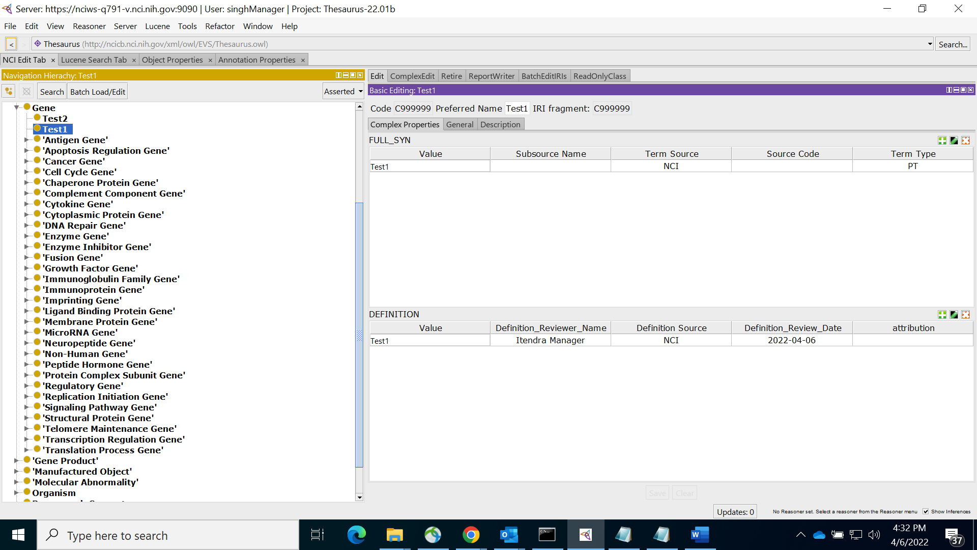

Editing ‘Test1’ and making it a child of ‘Cancer Gene’ :

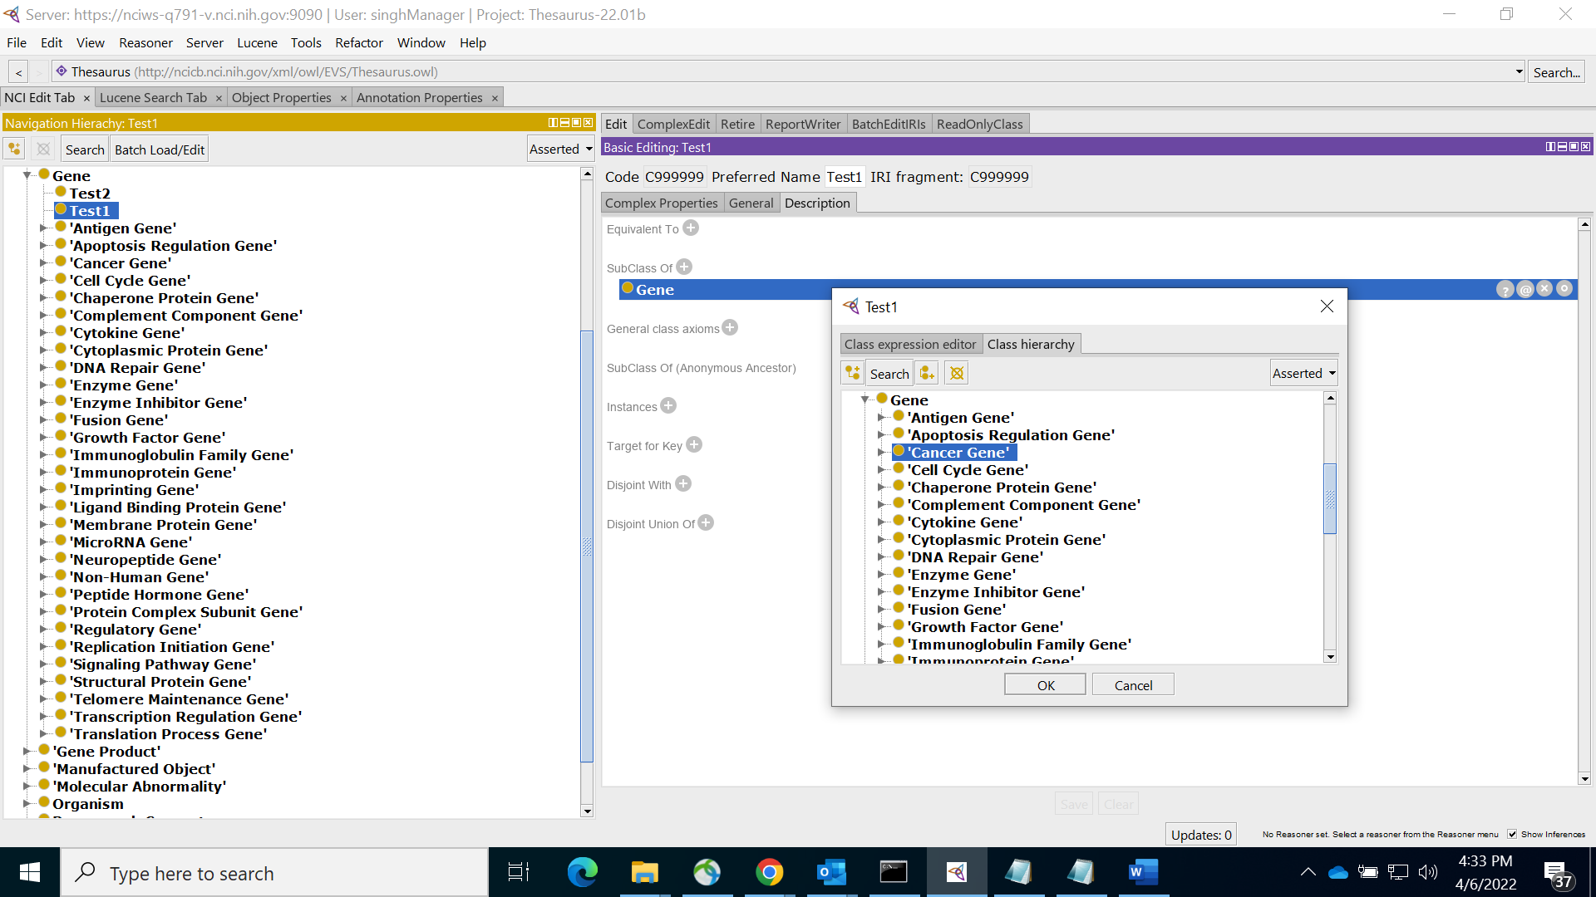

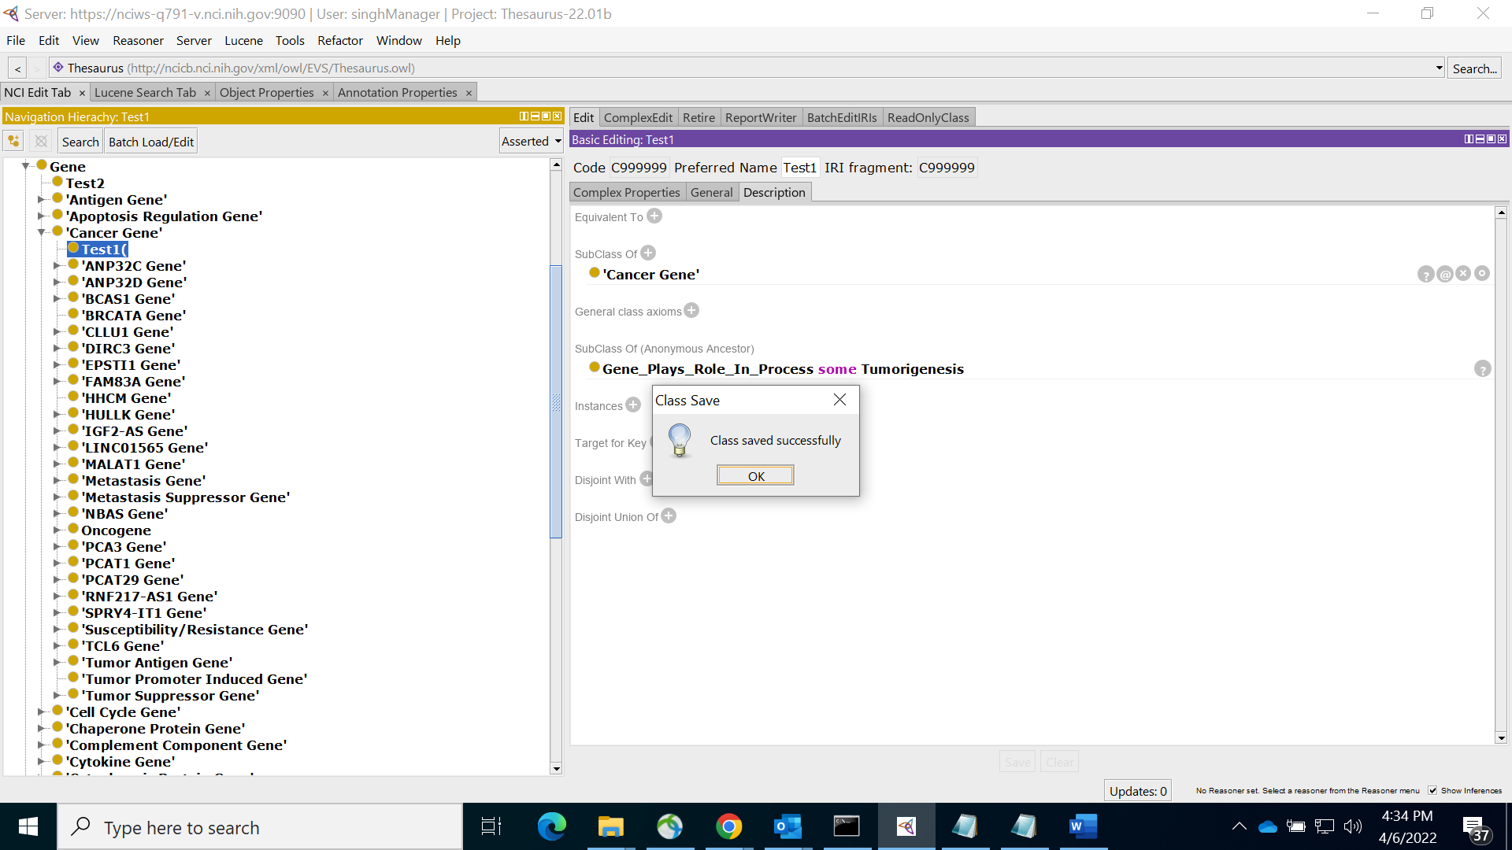

Editing ‘Test2’ with ‘Cancer Gene’ & ‘Test1’ as Parents while keeping ‘Gene’ parent as-is :

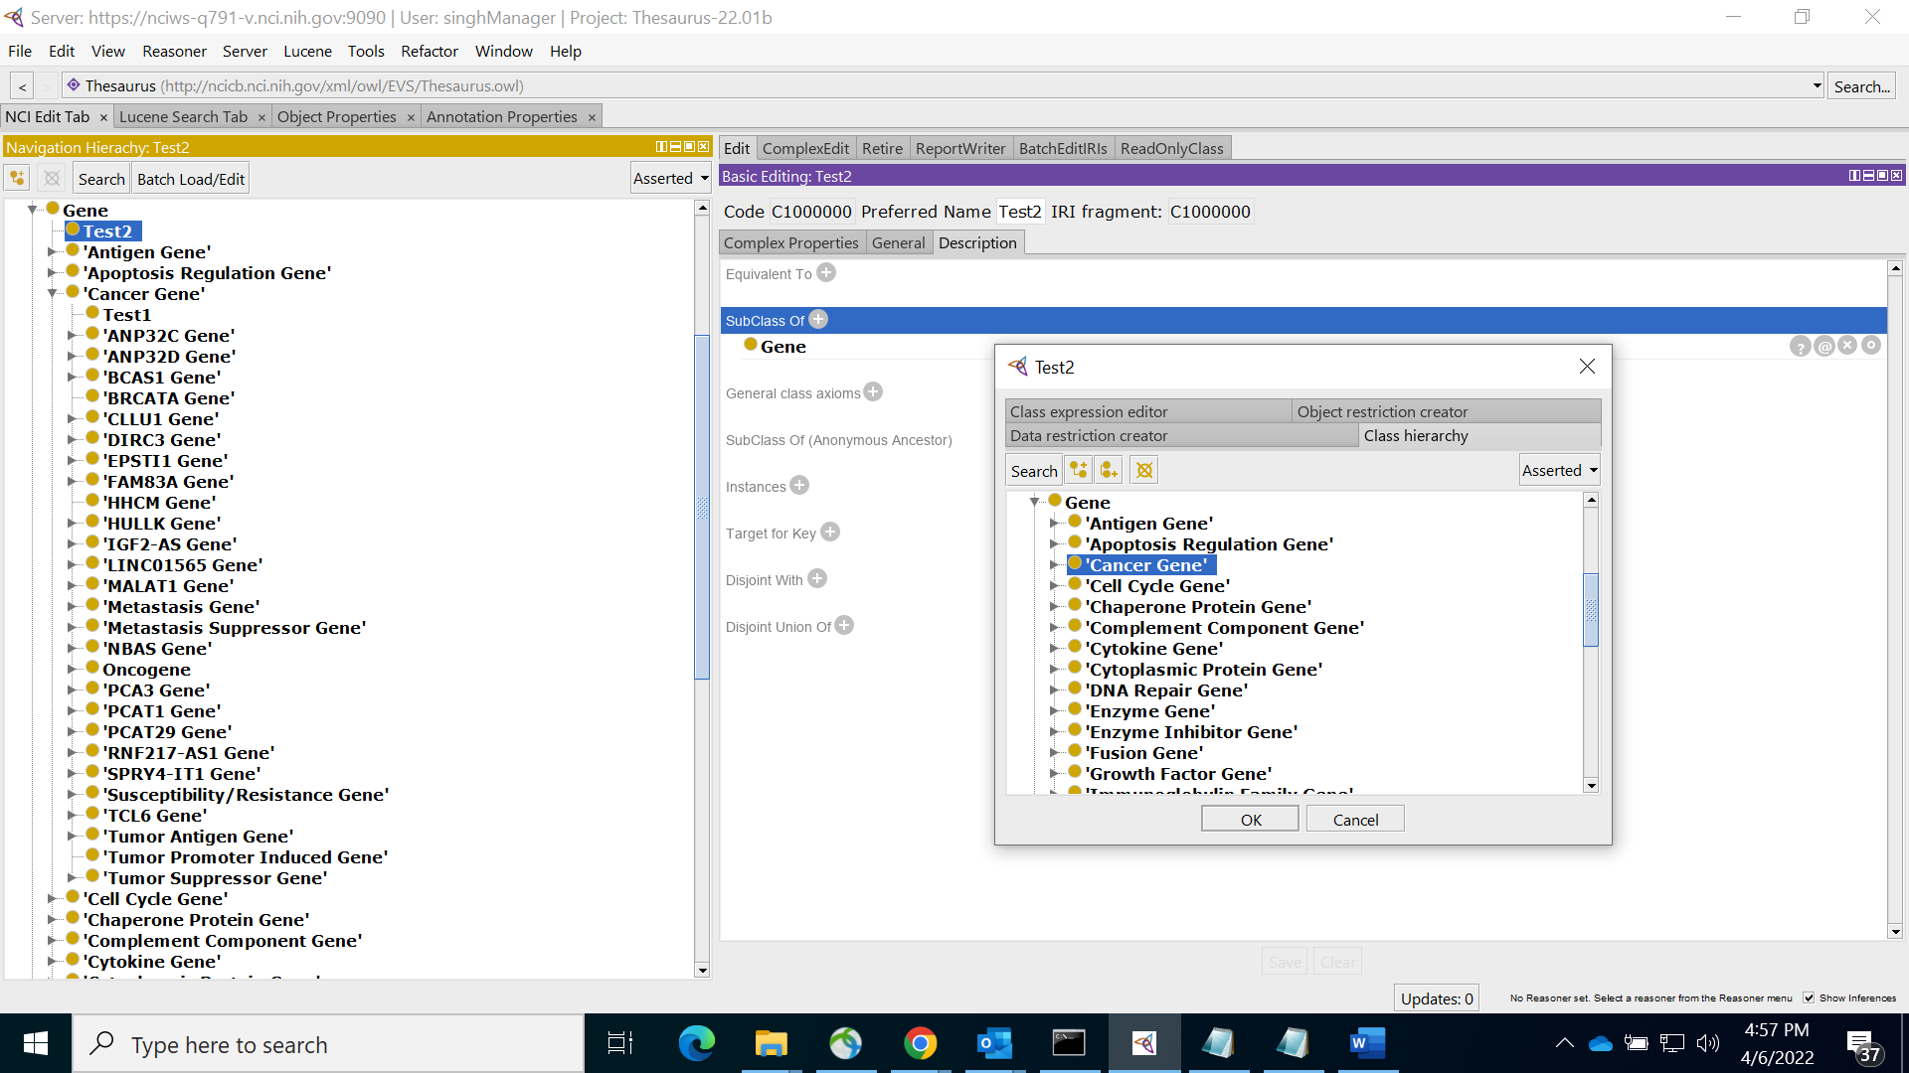

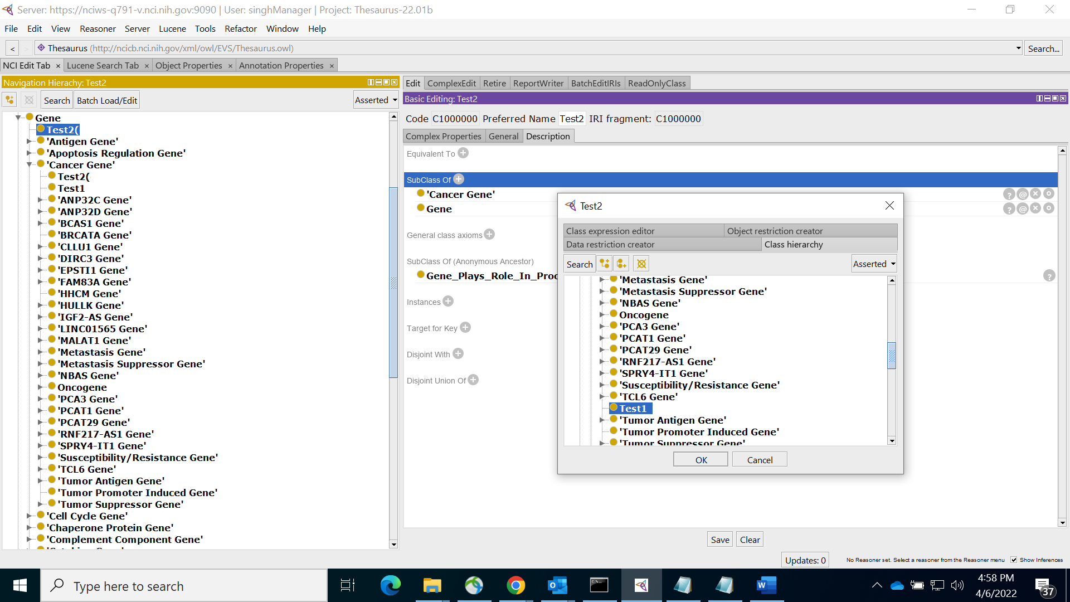

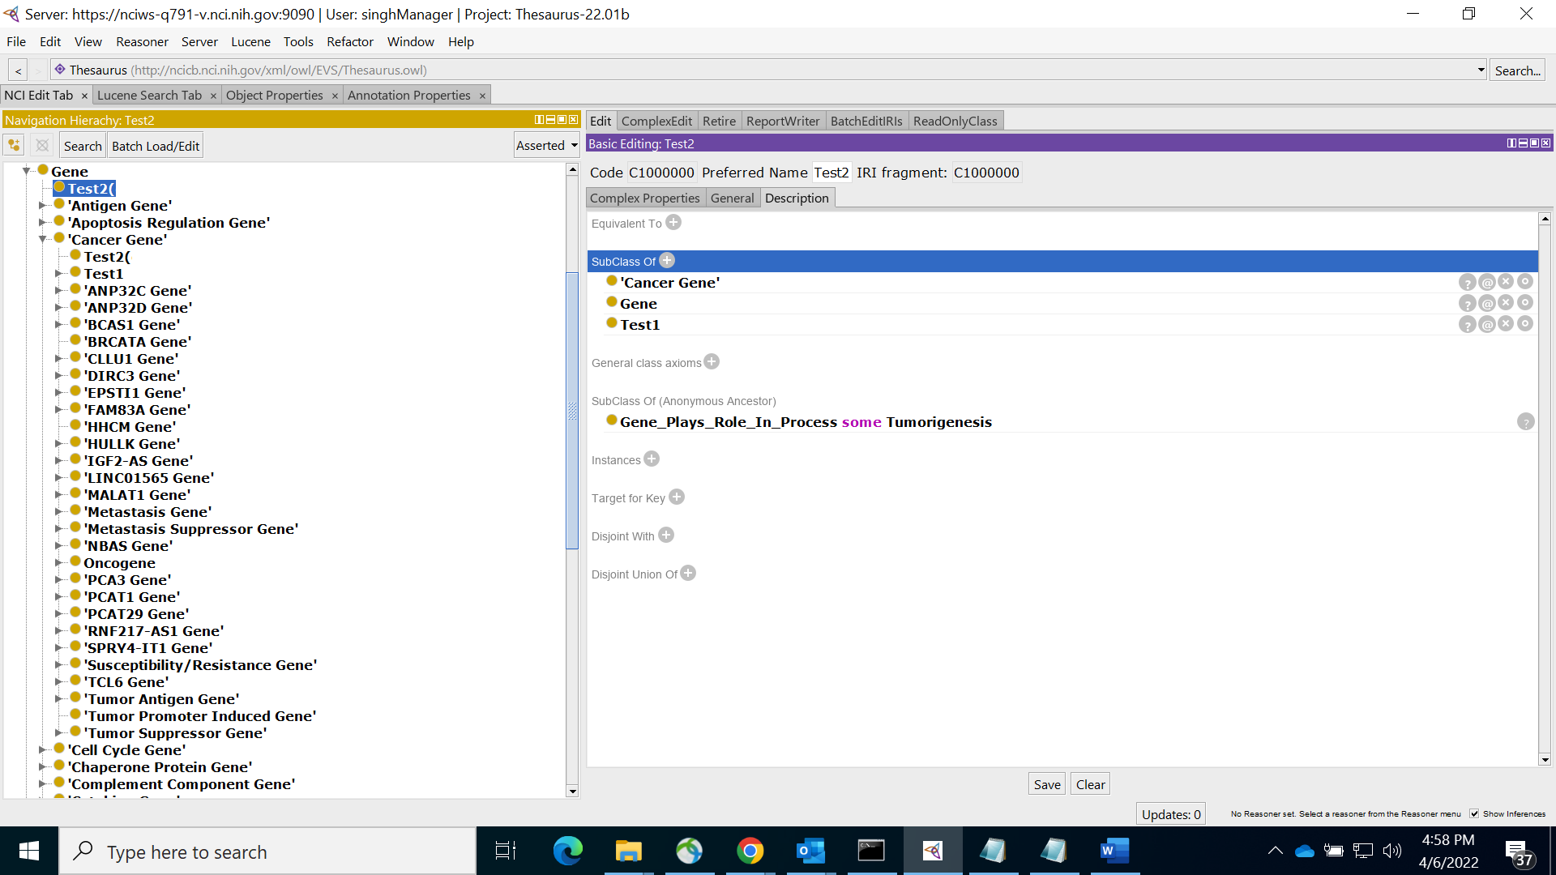

‘Test2’ is saved successfully, An Error of Parent Redundancy should have been Thrown, THIS IS WHAT THE TICKET SEEKS AS IMPLEMENTATION :: DEFECT

