## Path injection of Flask String type under Windows

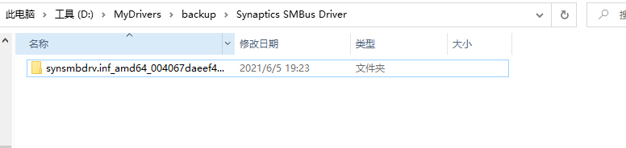

Code

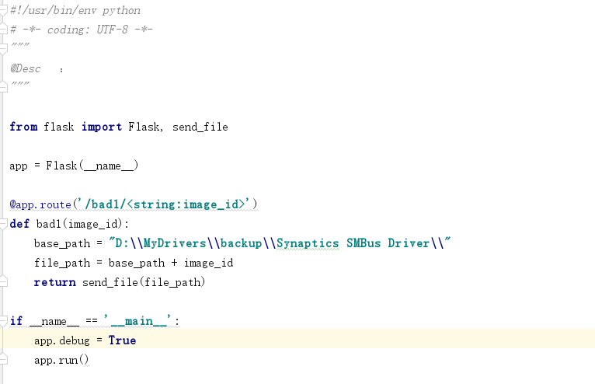

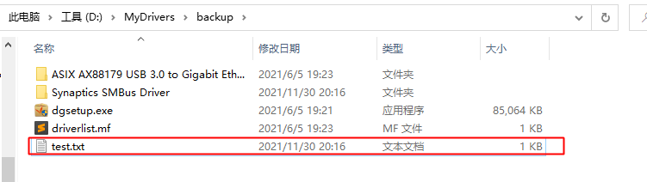

curl -v http://127.0.0.1:5000/bad1/..\\test.txt

