**With firefox 46 and old AXE tool:**

Initially we have run the pnr on firefox version 46.0 with the respective AXE tool add on.In this case the axe tool doesn’t report any accessibility issues or voilations.For your reference you can see the below screenshots.For selectpax page and display pnr page.

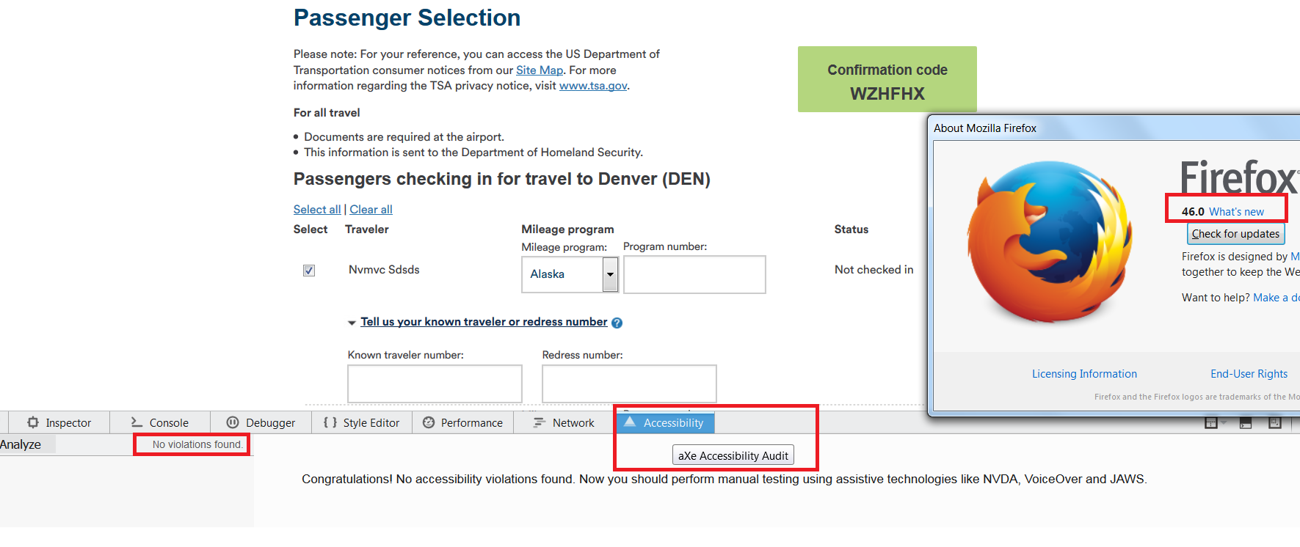

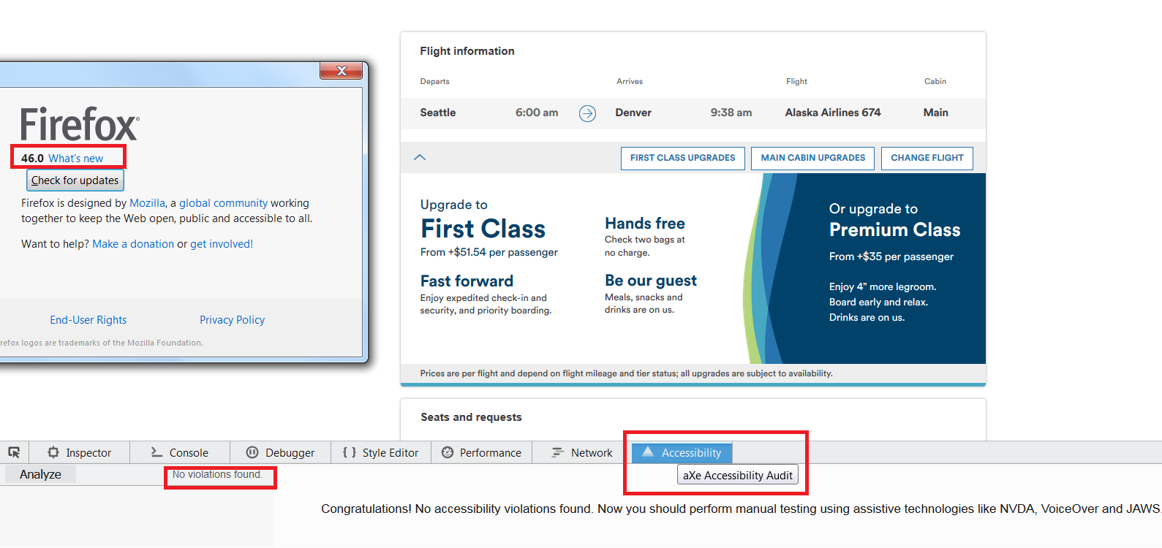

And when I try to add the new add on axe tool to the firefox version 46.0, it is showing some error ,as the latest version of AXE tool requires the 54 or above version of firefox. So I downloaded the latest version of firefox with the latest AXE addon.

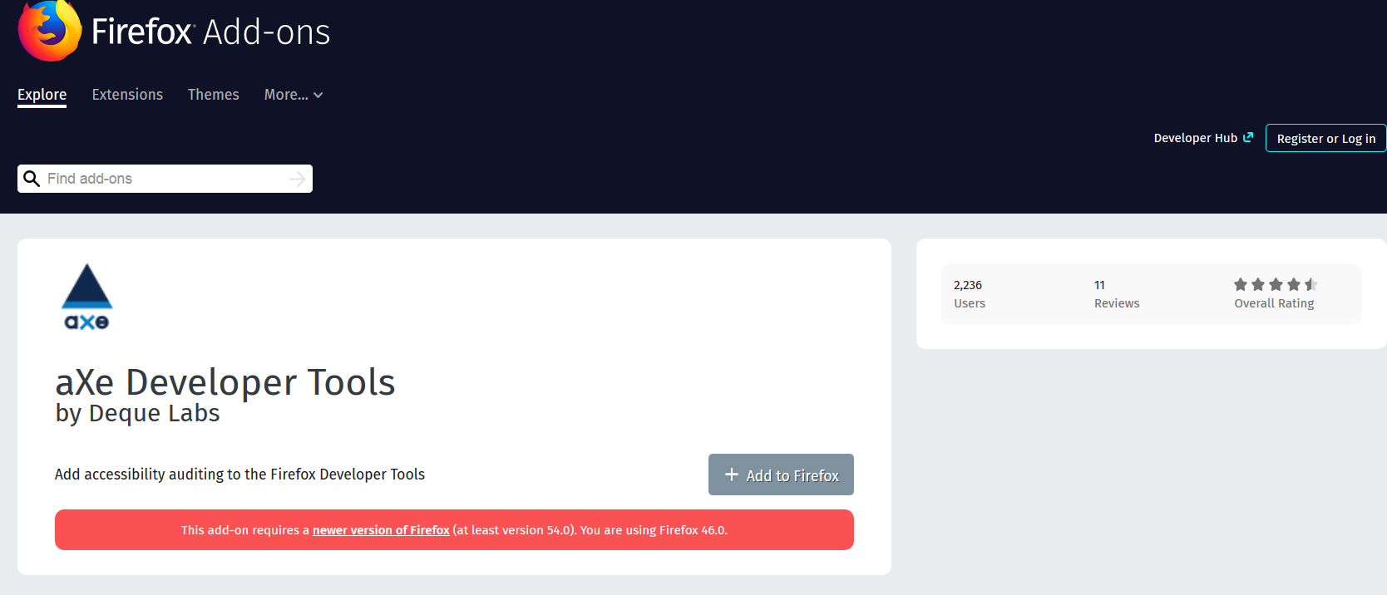

**With Firefox 57 and latest AXE tool:**

On the select pax page with the latest axe tool is showing some warnings regarding the color contrast with the new version of firefox.So I downloaded the color contrast analyzer for firefox and performed the color check for foreground and background on the respective texts.The color contrast analyzer is passing all the warnings.For your reference please see the below screenshots.Please confirm whether these warnings are to be considered or not.

**Issue1:**

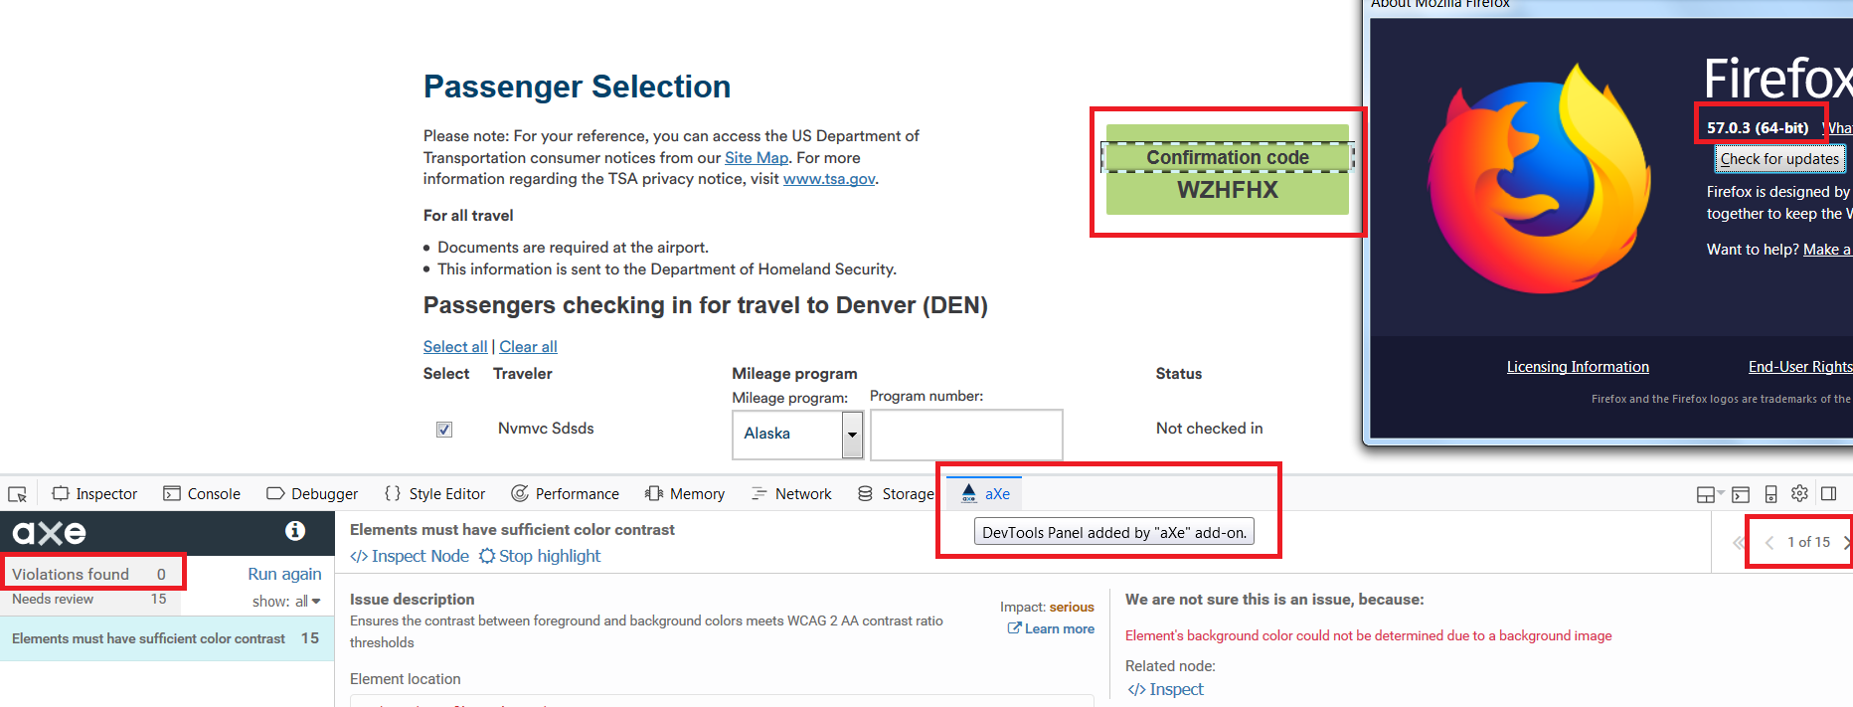

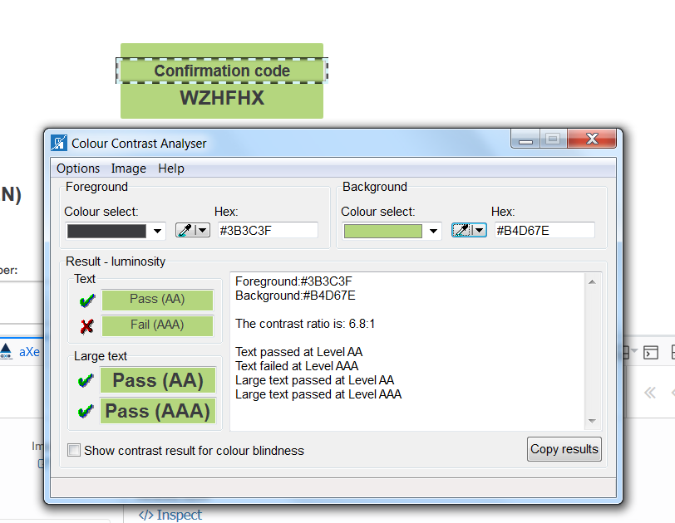

**Issue2:**

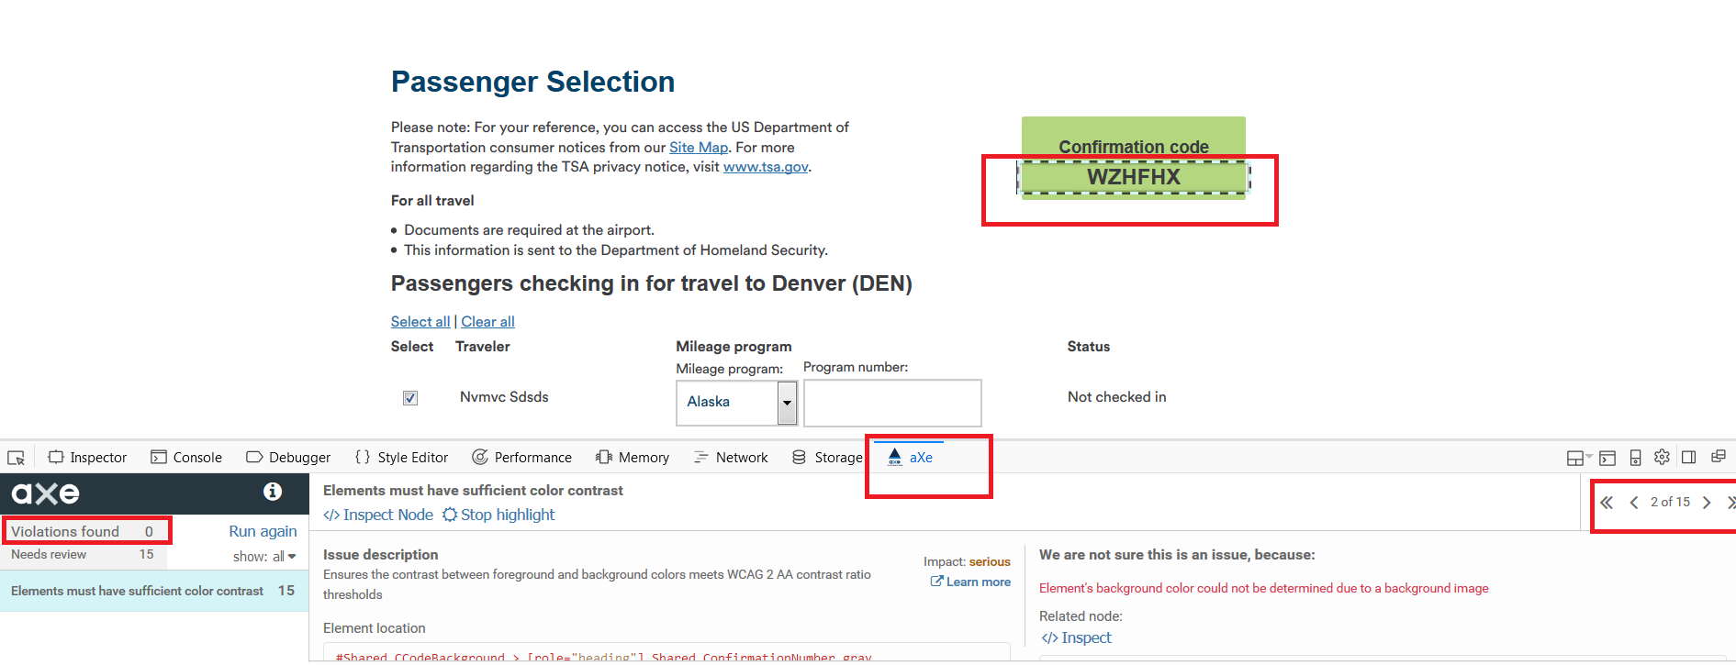

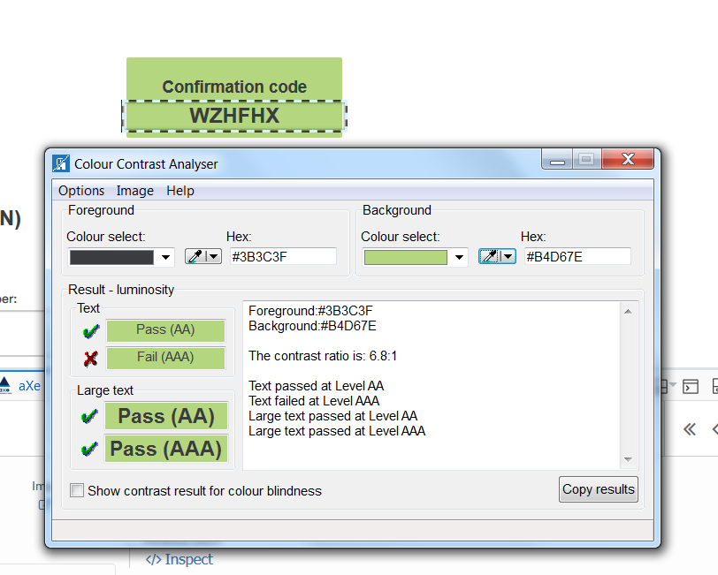

**Issue3:**

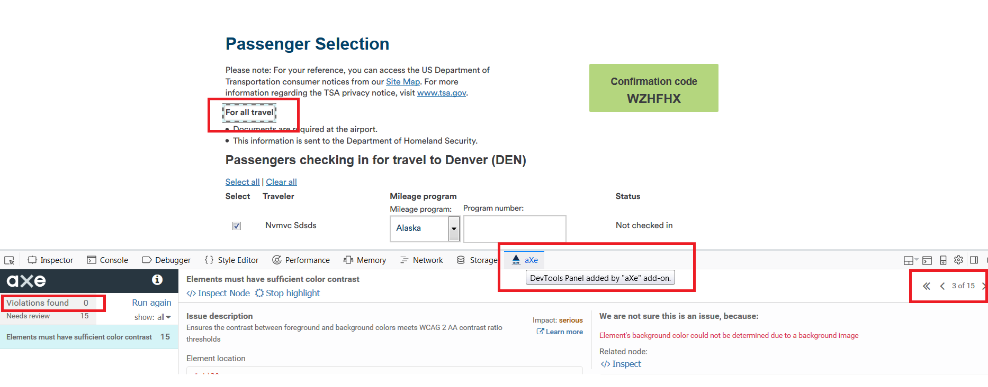

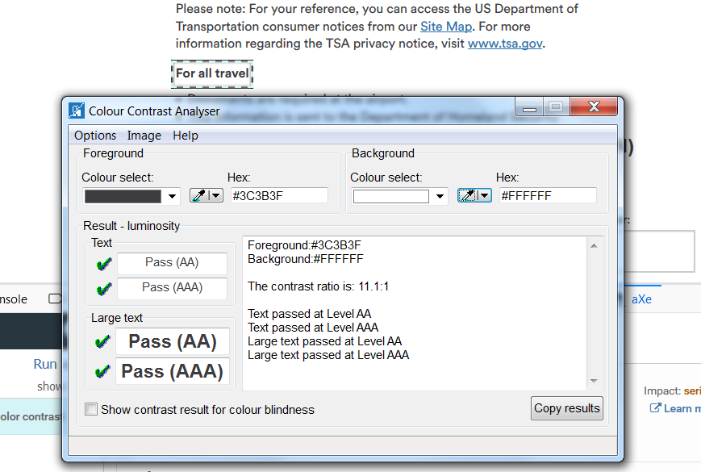

**Issue6:**

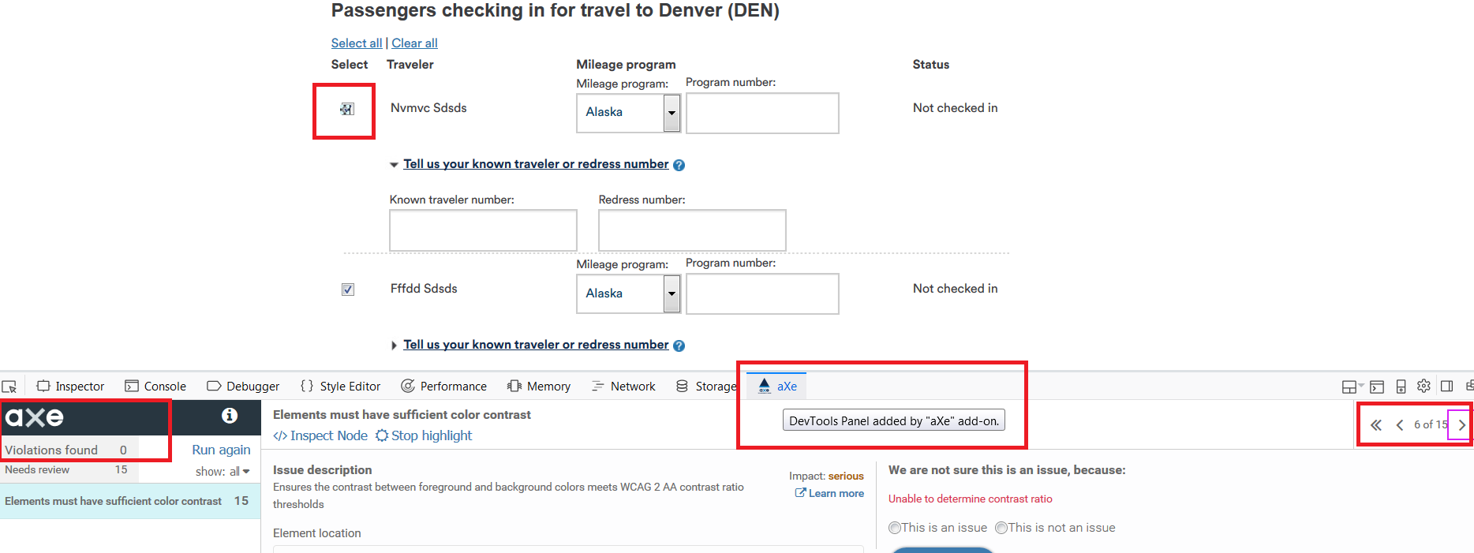

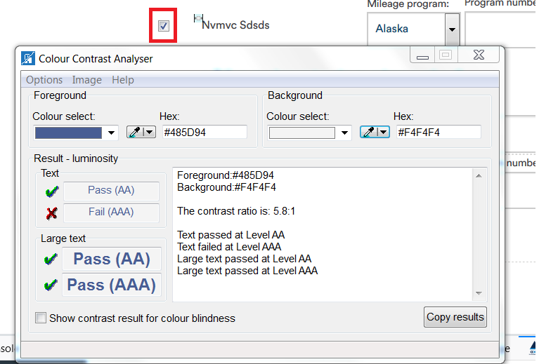

**Issue9:**

But in the below screenshot you can see one warning below the **Mileage program** header but there is no any control or text that is visible at that particular place(you can see it in second screenshot) still it is showing some warning at that place .Please confirm whether it is an issue or can be ignored.

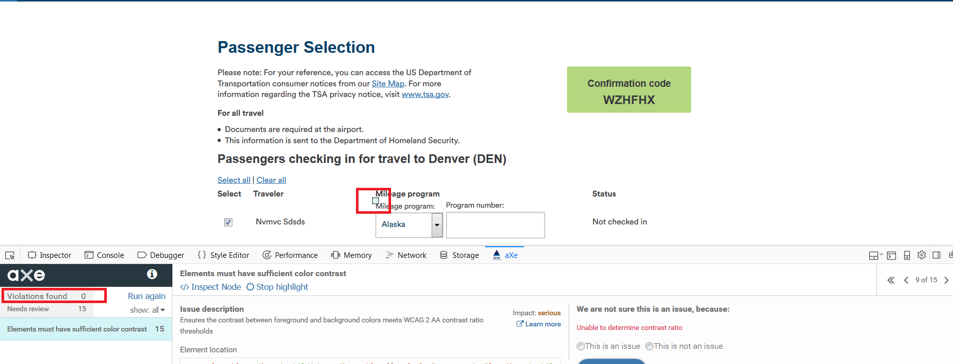

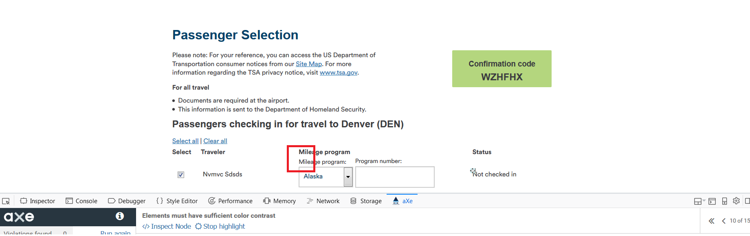

Here if we observe in the below screenshot AXE itself is announcing there is an error with the code regarding the AXE rule . Hoping as some inconsistency with the AXE tool. Please confirm on this .For your reference please see the below screenshots.

