I want to share some Martingale/non-Martingale ideas I have kept as resources.

1) Since we are into betting automation, if you have not heard of MT2Trading, it is a software that links to both a binary broker and MT4 platform to automate binary options based on a selected indicator.

One feature of MT2Trading is a martingale setting:

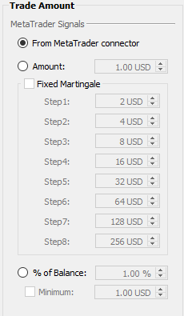

<https://www.mt2trading.com/docs/martingale/>

This is a big leap in programming the PCS prediction bot since MT2Trading is Windows software (GUI). This is only for reference/inspiration.

2) It is well known martingale is risky but most straightforward. Alternative methods are more conservative but betting patterns are more complicated and take more time to recoup 100%.

Parouli: <https://bitcointalk.org/index.php?topic=1430193.0>

1.5 Multiplier and Fibonacci Progression: <https://www.forexstrategiesresources.com/breakout-forex-strategies/81-box-breakout-martingale-trading-method/>

3) 1 way to extend Martingale goes like this:

Base bet = 1

a) 1 = lose, 2 = lose, 1 = lose, 1 = lose, 1 = lose, 1 = win, 4 = win

b) 1 = lose, 2 = lose, 1 = lose, 1 = lose, 1 = win, 4 = lose, 1 = lose, 1 = win, 8 = lose, 1 = lose, 1 = lose, 1 = win, 16 = win

What this means is whenever a martingale bet loses, betting automation reverts to base bet (or fixed bet of 1) and bets on 1 until it wins then doubles on the next stage of martingale bet.

4) This is my favourite betting method as it only applies martingale to the ‘first’ losing bet; no martingale on subsequent losing bets.

Please familiarize by playing with numbers in the accompanying Excel sheet.

Explanation: 1 set has 5 betting rounds. For stating capital of $2500, you risk $5 in round one. If you win, you claim $5 + 70% reward = $8.5 (It’s 9 in Excel because I round off to whole numbers).

It is understood that your first profit is “170% Reward” - “Risk Amount” = $3.5. Now, you take 70% out of $3.5 to bet on round 2. If you lose this round, you still have 30% x 3.5 = $1.05 profit and you go back to 1st round base bet.

If you win 2nd round, no more “170% Reward” subtract “Risk Amount”. Just take 70% out of “170% Reward” and bet 3rd round. If lose 3rd round, you still have 1st round 30% leftover profit + 2nd round leftover profit. Go back to 1st round base bet.

Keep winning 5 consecutive rounds and restart a new set.

I must have bookmarked the web page that explains this but I can’t recall the domain name or page title.

5) Combine points 4 and 3 and I can’t see why you would go bankrupt! Only problem is it will test binary traders’ patience to “work full-time”.