# Pillow + Tidelift marketing tests

## Payment for workable leads

We’d like to run as many of the following tests as you are comfortable with for 3 months to see if we can get a higher conversion of leads. We’d also like to test paying for what we deem “workable” leads. We still need to put pen to paper on what the actual agreement looks like, but in Tidelift form it would be simple and to the point.

Generally speaking we're thinking about something like this:

1. Rate: $50/workable sales lead (for any net new leads to our database)
2. Workability: Tidelift Sales will review all lifter leads and determine the quality of the lead. “Workable” means a verifiable individual who could potentially lead to a purchasing process / conversation.
3. Tracking: We will generate a unique tracking link so we can track leads by Lifter.
4. Payment Frequency: Finance will deposit the funds into your Hyperwallet account at the same time as your current Lifter payment and send you a separate receipt.

**\*Please note:** Because the way we will trace these leads is via a tracking code (called a UTM parameter), you will need to include the tracking at the end of your URL. Each parameter will be slightly different depending on the medium. For example, leads coming from your websites or docs will be “referrals”; leads coming from Tweets will be “social.” I am including the URL for each below in the section they belong.

## Pillow for enterprise

We’d like to test “Pillow for enterprise” as the way of introducing the concept of Tidelift to your users.

We’ve been testing this on both [Vuetify](https://vuetifyjs.com/en/) and [Project Lombok](https://projectlombok.org/) to good results so far:

* Both sites’ referral traffic has increased by over 100% in our month-long week testing period
* Both sites’ workable leads have doubled since the changes, increasing their monthly payout by hundreds of dollars. We think this is just the beginning.

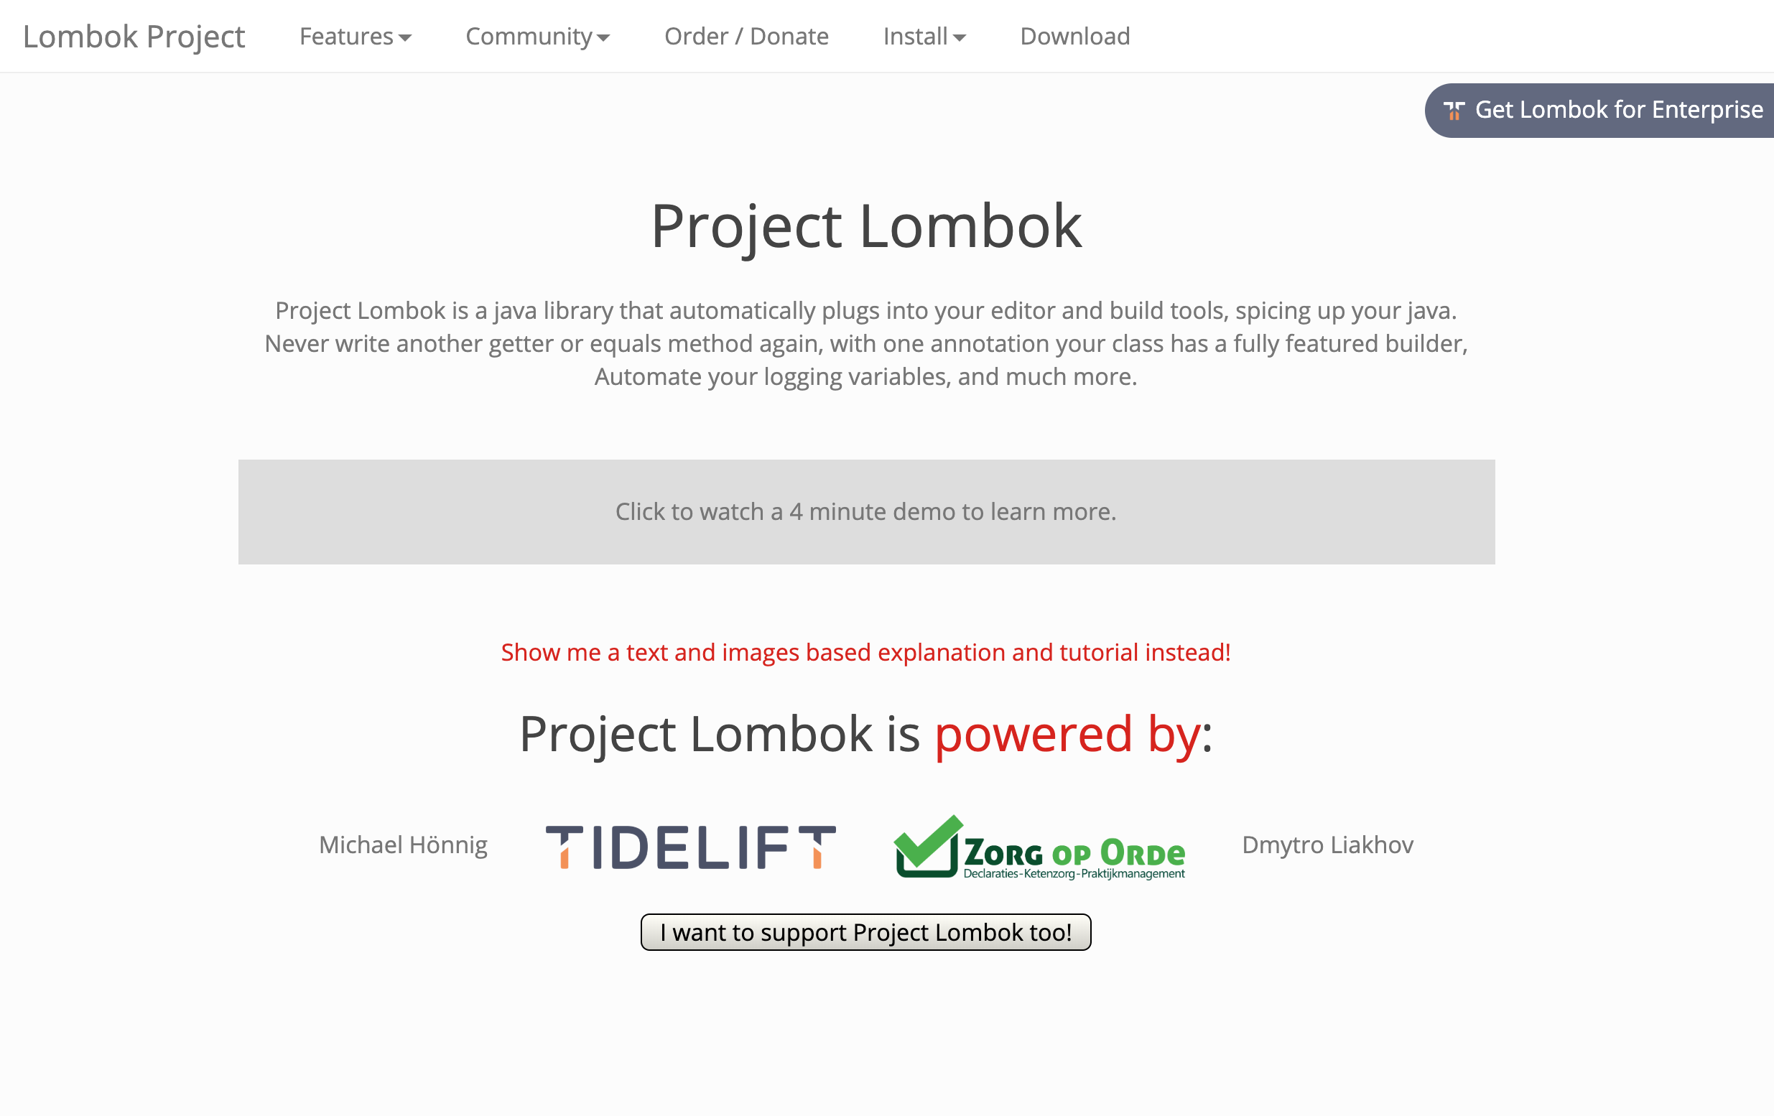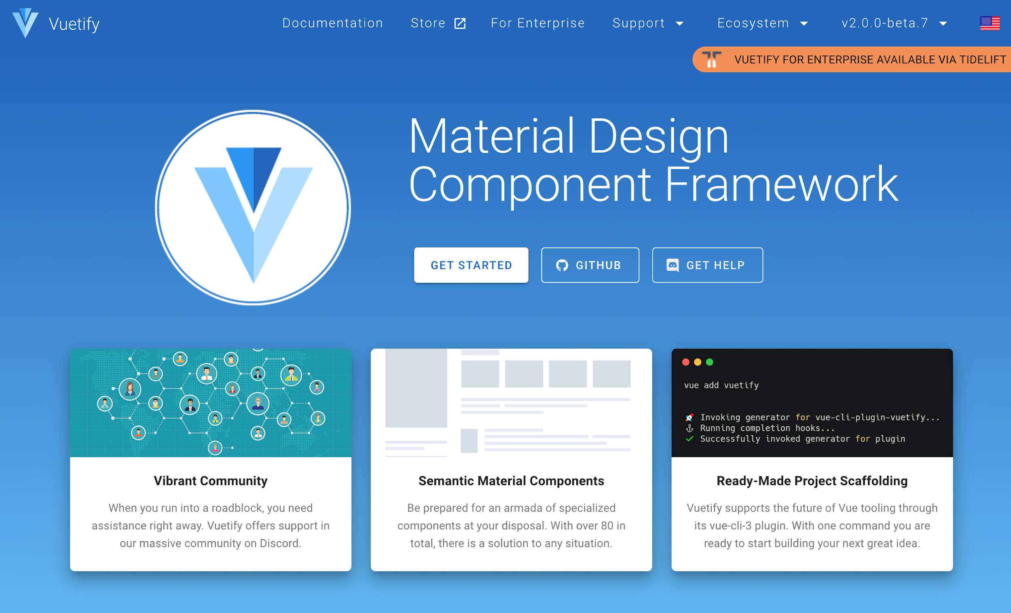

Here’s how it works:

### Website updates

#### Header updates

Add “Pillow for enterprise” button either next to or below the GitHub button.

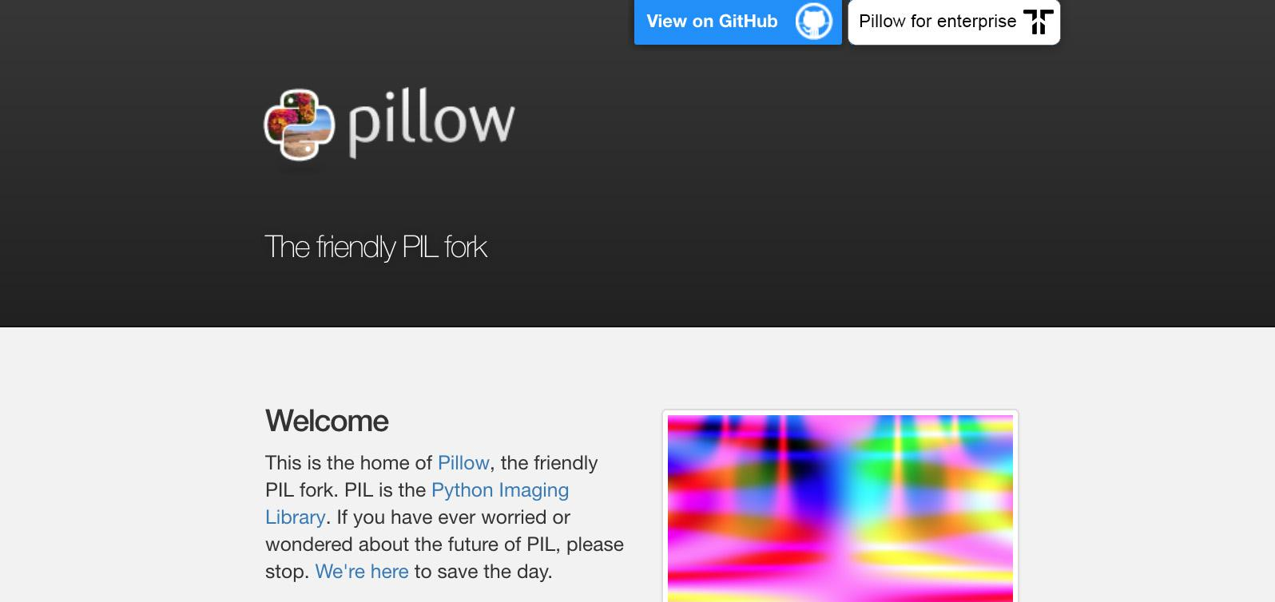

* UTM parameter:

<https://tidelift.com/subscription/pkg/pypi-pillow?utm_source=pillow&utm_medium=referral>

#### Docs updates

Add “For enterprise” to the navigation on the docs. Also add “Pillow for enterprise is available via the Tidelift Subscription. [Learn more](https://tidelift.com/subscription/pkg/pypi-pillow?utm_source=pillow&utm_medium=referral&utm_campaign=docs).” below the description.

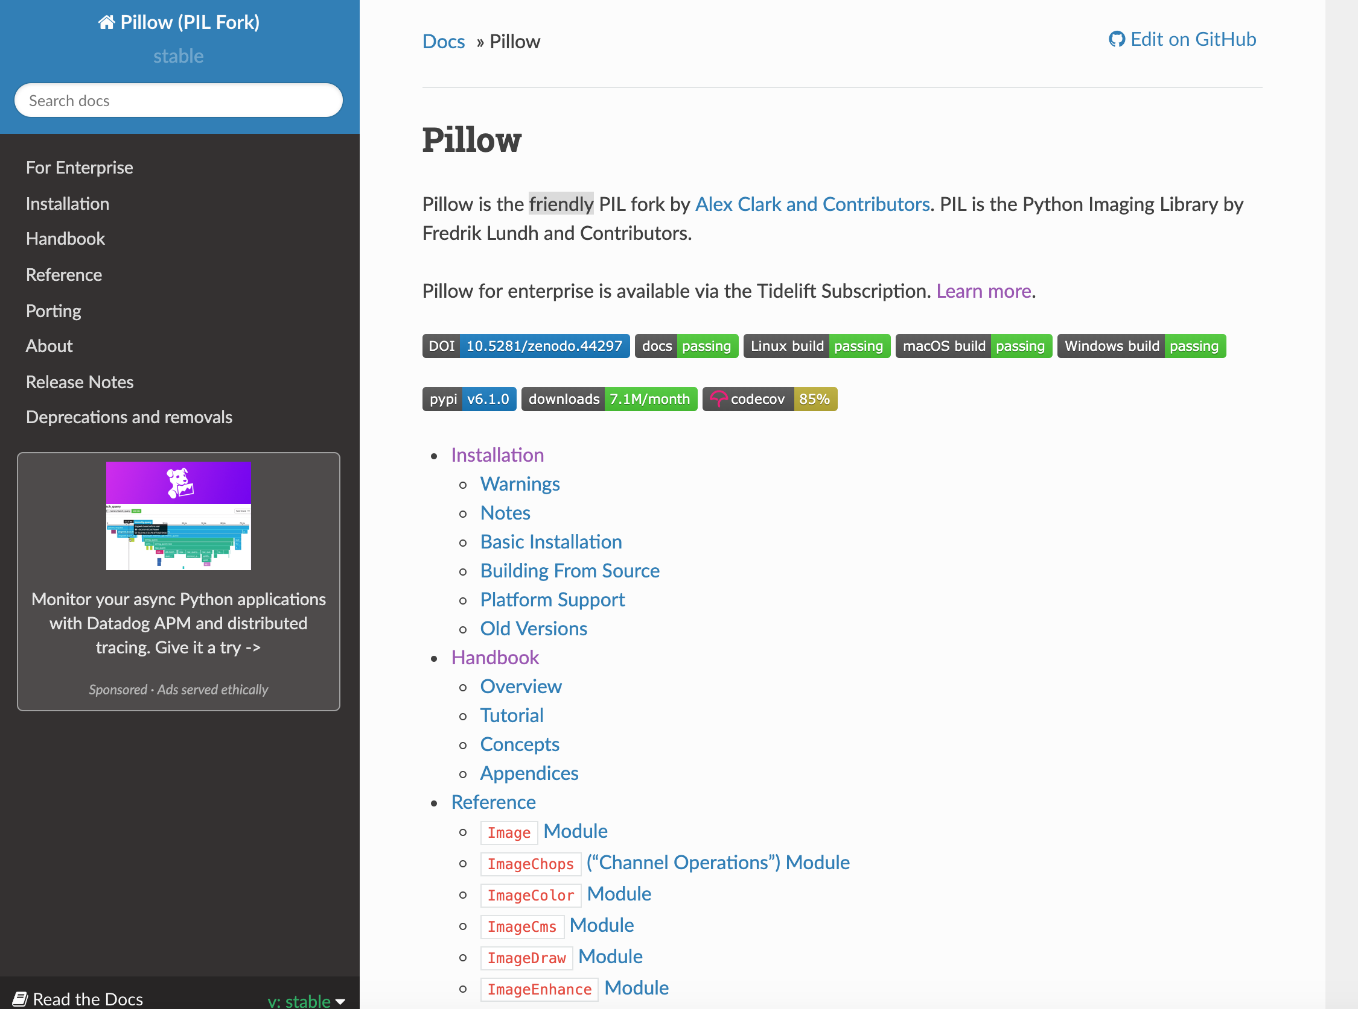

URL: <https://tidelift.com/subscription/pkg/pypi-pillow?utm_source=pillow&utm_medium=referral&utm_campaign=docs>

## Social

Promotion via Twitter or other social networks (such as LinkedIn, which is particularly successful). We’d love to test some language with your audience. We were thinking one post per week, maybe on a Tuesday or Wednesday morning (when an enterprise audience is most likely reading). Social post ideas:

* Pillow for enterprise is now available via the Tidelift Subscription.
* Get a managed open source subscription, including Pillow, via the Tidelift Subscription.
* You can now get professional support for Pillow and all of your open source dependencies via Tidelift.
* UTM parameter:

Learn more page: <https://tidelift.com/subscription/pkg/pypi-pillow?utm_source=pillow&utm_medium=social&utm_campaign=summertest>

Demo page: <https://tidelift.com/subscription/request-a-demo?utm_source=pillow&utm_medium=social&utm_campaign=summertest>

## Email

If you have an email list and would like to experiment with promotional emails, we’ve created some sample text. We’re happy to work with you to revise the copy so that it works for your audience. We’d suggest only sending once this summer, preferably on a Tuesday or Wednesday morning when an enterprise audience is more likely to be reading. We can also use our email program to send for you.

* Sample email [here](https://docs.google.com/document/d/1AH49Z2yZNDb-wdAiuJTlRl0A2NFqU8mYqq-ygH35Zls/edit?usp=sharing)
* UTM parameter:
  + Learn more button:
    - <https://tidelift.com/subscription/pkg/pypi-pillow?utm_source=pillow&utm_medium=email&utm_campaign=summertest>
  + Request a demo button:
    - <https://tidelift.com/subscription/request-a-demo?utm_source=pillow&utm_medium=email&utm_campaign=summertest>