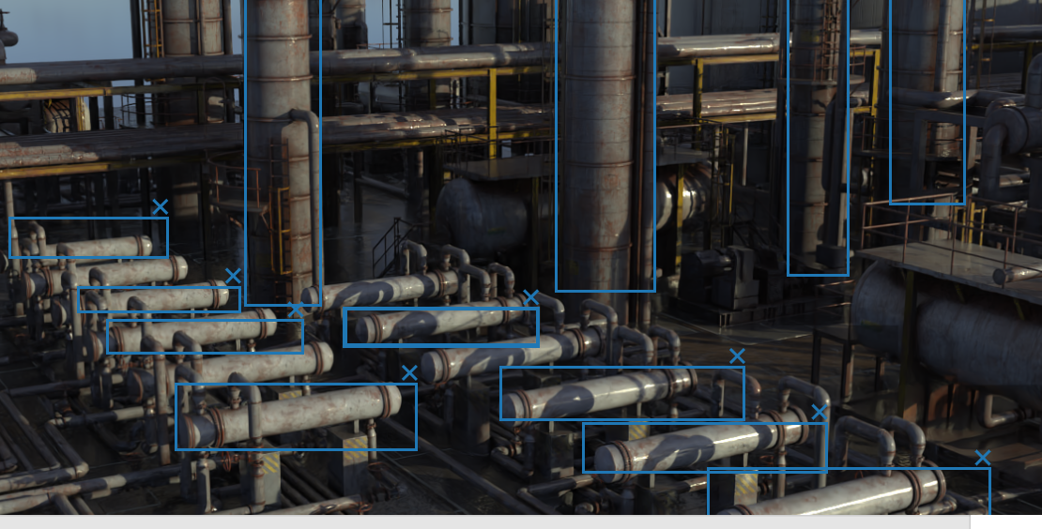

Want to label these parts and detection should happen with the labels